CSS NOTES.

* Adjacent selector:
* We have to use ‘#’ while accessing elements with id.

Syntax:#maindiv h1 +p {color:red;}

It will apply this property to all adjacent p’s of h1.

* Background Attachment property.
* This property sets the position of image whether it is scrolled or not.

By default,its value is scrolled.

Background-attachment:fixed/scrolled;

* Background clip:
* This property is used to set the painted area of the background.it has three attributes:

1. Content Box:fills the color with contents.
2. Border Box:fills the color with border.
3. Padding box:fills the color with padding.

Syntax:background-clip:content box/border box/padding box.

* Background color:
* This property is used to set the background color of the screen.we can mention color in three ways:

1. Using hex value.

Background-color:#FFFFFF;

1. Using rgb value.

Background-color:rgb(234,90,245);

3.using color name.

Background-color:red;

* Background Image:
* This property is used to set the background image to the screen.by default,it is set to repeat.we have to mention background color with image which will be displayed if image is unable to load.

Syntax:background-image:url(rohit.jpg);

* Background origin property:
* This property is used to set the origin of image.by default,its value is set to padding box.
* it has three attributes:

1.Content Box:sets an image from top left corner of the contents.

2.Border Box:sets an image from top left corner of the border.

3.Padding box:sets an image from top left corner of the padding.

Syntax:background-padding: content box/border box/padding box;

* Background position:
* This property is used to set to set the position of the image on screen.by default,its value is left top.we can set this property to left top, left bottom,center left,center center,left bottom,right bottom,x% y%,x-position y-position.

Syntax:background-position:top left/top right/center center;

* Background-repeat:
* This property is used to set repeat property of an image.by default,its value is set to repeat.we canset this property to three attributes:repeat-x,repeat-y,no-repeat.

Syntax:background-repeat:no-repeat/repeat-x;

* Background shorthand:
* This property mentions all attributes of background property in single peroperty.it mentions background-color, background-image, background-repeat, background-attachment, background-size.

Syntax: background: url(a.jpg) no-repeat right bottom;

* Background-size:
* This property is used to set the size of the image.this property contains two keywords:

1.cover:this property sets an image on the screen as large as possible.

2.contain:this property sets the image fit to the screen.

Syntax: background-size: cover/contain;

* Display:
* Block-level:this property enabled elements always start on new line.it takes space as much as possible.

Ex:<div>,<p>,<h1>.

* Inline:this property enabled instructions does not create new line.it takes space which necessary.

Ex:<span>,<img>.

Syntax:inline/block;

* Border-Bottom-Color:
* This property is used to change color of the border.this property takes two attributes:color name and transperant.

Syntax: border-bottom-color: transparent/red;

* Border-bottom:
* This property is the shorthand of border-bottom-color, border-bottom-style, border-bottom-width.

Syntax: border-bottom: 3px solid red;

* Border-Bottom-style:
* This property is used to set the line style of the border.we can set value like solid,dashed,hodden,none,dotted,double,groove,ridge.

Syntax: border-bottom-style: ridge;

* Border-collapse:
* This property is used with table border.this property sets whether table borders are collapsed into single line or detached.it takes two attributes:separate and collapse.

Syntax:border-collapse:collapse/seperate;

* Border-left:
* This property is used to set the style,width and color of line in one property.

Syntax:  border-left: ridge 20px violet;

* Border:
* This property is used to set border on all sides in one property.it is shorthand of border-width,border-style,border-color.

Syntax:border:20px solid red;

This property provides border on all sides of the content.

* Border-rounded-corners:
* This property is used to set rounded corners of border.it has four separate properties and one shorthand property:

1.border-top-left-radius.

2. border-top-right-radius.

3. border-bottom-left-radius.

4. border-bottom-right-radius.

5.border-radius.

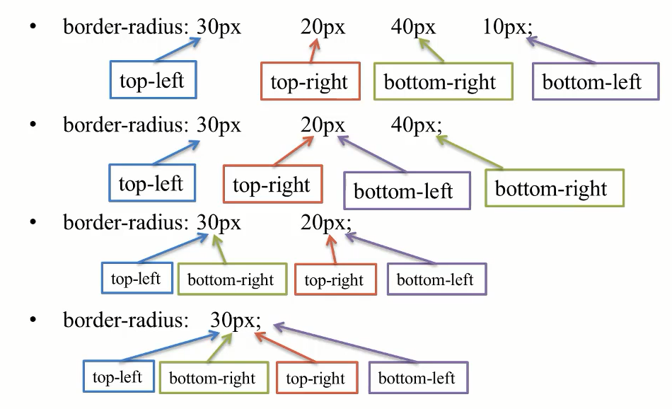

* We can use this property to image also.
* Border-spacing:
* This property is used to set space between two borders in table,it is used with separate attribute.

Syntax:border-spacing:5px 10px;

* 5px represents horizontal space and 10px represents vertical space.
* Font shorthand property:
* This is shorthand property to style the font.it takes following attributes:font-style,font-varient,font-size,font-family.

Example:font:bold 20px serif;

* In this property,font-size and font-family attribute are mandatory.
* Font-family:
* This property specifies the family of the font.we can specify more than one font names to this attribute.if font name is more than one word,then we have to mention it in double quotes(“ “).

Example:font-family:Arial,serif,”times new roman”;

* Font-size:
* This property is used to specify the size of the font.we can specify size in terms of pixels,percent and em.
* 1em=16 px,default font size is 16px.

Example:font-size:20px/20%/2em;

* Font-stretch:
* This property specifies condensed,normal and extended font face.some more attributes are:normal,wider,narrower,ultra-condensed,extra-condensed,condensed,semi-condensed,semi-expanded,expanded,extra-expanded,ultra-expanded.

Example: font-stretch: ultra-expanded;

* Font-style:
* This property is used to mention the font style of the font.it may be normal,italic,oblique.

Example:  font-style: italic;

* Font-varient:
* This property is checks whether or not font-varient is in small-caps.it has only two values:normal,small-caps.
* It converts lower case font into uppercase and if it is in uppercase,then it will reamin as it is.

Example: font-variant: small-caps;

* Font-weight:
* This property is used to set the weight of the font.it takes values as bold,bolder,lighter,normal and you can also specify the number also.

Example: font-weight: bold;

* Text-align-last:
* This property is used to align last line of the paragraph.we can set this property to center,right,auto,left,justify,start and end.
* This property will work if text-align property is set to justify.

Example: text-align:right;

    text-align-last: right;

* Text-decoration-line:
* This property is used to specify what type of line decoration will have.we can set this property to underline,overline and line-through.
* You can specify multiple attributes to this property.

Example: Text-decoration-line:underline overline line-through;

* Text-decoration-style:
* This property is used to specify style of the line.we can set this property to dashed,dotted,double,solid,wavy.

Example:text-decoration-style:dashed;

* Text-decoration-color:
* This property specifies the color of the line.

Example: Text-decoration-color:red;

* Text-decoration shorthand:
* By using this property,we can specify text-decoration-color,text-decoration-style and text-decoration-line properties in single property.
* We can specify attributes in following sequence:text-decoration-line, text-decoration-style, text-decoration-color.

Example: text-decoration:underline solid red;

* White-space:
* This property is used to specify whitespace between words in paragraph.we can set this property to wrap,nowrap,pre,normal,pre-line,pre-wrap.description of these attributes is:

1.nowrap:this attribute provides scrollbar if your content is too long to fit in the screen.it does not move contents on new line.

2.wrap:do not provide scrollbar.if contents are long,then split them into new line.

Example: white-space: pre-wrap;

* Width and height in css:
* This property is used to set width and height property to block-level elements.it is not possible to set width and height to inline elements.
* If we specify the width and height in px,then contents may be loss if we change the size of browser’s window.but if we specify the width and height in %,contents will get managed according to size of browser’s window.
* Block-level elements acquires the width as much as possible,inline elements acquires only space required to display.

Example:width:200px;height:400px;

* Word-break:
* This property is used to specify line breaking rules for non-CJK scripts.we can set this property to normal,break-all,keep-all.
* Normal:default value.
* Break-all:break words if it is not fit till end of line.
* Keep-all:do not break word,move word to new line.

Example:word-break:break-all;

* White-space:
* This property is used to increase or decrease the space between to words.we can specify space in px also.

White-space:5px;

* Word-wrap:
* Word-wrap property allows to break word and wrap into new line.it is set to normal by default and to break-word.

Syntax:word-wrap:break-word;

* Z-index:
* This property is used to set the layer of the element.we can increase or decrease the priority of an element using z-index value.element with higher z-index having higher priority.we can specify z-index with number.

Example:z-index:12;

* Universal selector:
* It applies properties to all elements of the document.body will work similarly but it is unable to override properties set by browser.
* Universal selector overrides properties set by browser also.
* We are using \* for universal selector.
* Universal style class:
* In this property,classname is used with dot operator and inside its body,mention properties which we want to set to tags who has same classname.
* Multiple elements can have same class name.

Example:.accept{}

* Vertical-align:
* This property is used to position the text inside an element.we can set this property to super,sub.

Example:Vertical-align:sub/sup;

* Visibility:
* This property sets the visibility of the element.it can be set to two values:collapse and hidden.
* hidden:it will disable the content without removing it.
* Collapse:it is used with table to remove rows or columns.it does not affect the layout of table.

Example:visibility:hidden;

* Table height and width:
* This property is used to set the width and height of table,table header and rows.we can specify size in percentage or pixels.

Example:width:30%;height:90px;

* Table padding:
* This property is used to set padding between border of the table and contents.

Example:padding:3px;

* Flex-Direction:
* This property is used to set the direction of flexible items.if item is not flexible,this property will not work.by default,this property is set to row.
* This property is also set to row-reverse,column,column-reverse.

Example:     display: flex;

    flex-direction: column-reverse;

* Flex-wrap:
* This property is used to set wrap property if browser’s window resizes.

This property ise set to wrap,nowrap and wrap-reverse.

Example:flex-wrap:wrap-reverse;

Justify-content:space-around;

* Flex-flow:
* This property is shorthand of flex-flow and flex-direction.we can mention the values in sequence of flex-direction to flex-wrap.

Example:flex-flow: row-reverse wrap;

* Link properties:
* This property is used to style html links.this property sets properties for active,visited and for link.
* Link:this is used to set default presentation of link,
* Visited:this is used to set action when link is visited.
* Active:this is used to set action when link is in action.

Example: a:link{ color: hotpink;}

a:visited{color: black;}

a:hover{color: yellow;}

a:link{color: red;}

* Flex-grow:
* This property is used to set the width of an element,such that how an element can grow,if flex property is disable,then this property will not affect.by default,this property is set to 0.

Example:Flex-grow:2[

* Flex-shrink:
* This property is used to define how much an item will shrink.this property is set to 1 by default.

Example:flex-shrink:3;

* Float and clear:
* This property is used to specify that element should be placed to left and right side of the container.this property specifies where to the next element should be placed.it takes two values:left,right,none(default).

Example: float: left;

* Clear property is used to decide whether element should be next to the floating element or below them.this property is set to left,right,none(default).

Example:  clear: left;

* Text-align:
* This property is used to set the alignment of an element.it can be set to left,right,center and justify.

Example:text-align:center.

* Text-shadow:
* This property is used to provide shadow to text.you can more than shadow to same text separated by comma.
* H-shadow:position of horizontal shadow.
* v-shadow:position of vertical shadow
* blur-radius:this property is used to specify blur value of color.
* Color:color of the shadow.

Syntax:text-shadow:h-shadow v-shadow blur-radius color;

Example:  text-shadow: 10px 10px 3px red;

* Text-transform:
* This property is used to transform text to lowercase,uppercase and to capitalize.
* Example: Text-transform:capitalize;
* How to change color of text:
* This property is used to set color to text,oyu canspecify color as colorname or rgb value.

Example:color:red;

* Text-direction:
* This property is used to set the direction of text.ltr is default value.you can change it to rtl.

Example:text-direction:rtl;

* Text-indent:
* This property is used to provide indentation to the first line of paragraph.you can provide negative values also.

Example:text-indent:40px;

* !important:
* This property having highest priority in all elements in css.

Example:p{color:red !important;}

* Justify-content:
* This property is used to align flexible container’s elements.this property is set to flex-statr,flex-end,space-between,space-around.
* Flex-start:align element to beginning of the container.
* Flex-end:align element to end of the container.
* Space-between:used to align elements to keep space between elements.
* Space-around:used to align elements with space before,after and between the lines.

Example:justify-content:space-between;

* List-style-image:
* This property is used to set image to list elements.it is used to desing lists.

Example:list-style-image:url(‘book.png’);

* N-th child:
* This property is used to select elements from list of elements.we can select element by specifying name or as even/odd notations.also you can apply formula also to find particular element.

Example:li:n-th element(5){color:red;}

* List-style-type:
* This property is used to set style of a list.for unordered list,we can set this property to circle,square,disc and for ordered lists,it is set to decimal,lower-alpha,upper-alpha.

Example:list-style-type:disc;

* List-style:
* This is a shorthand of an list styling.its parameters are list-style-type,list-type-image,list-style-position.

Example:list-style:disc url(‘a.jpg’) inside;

* List-style-position:
* This property is used to position a list elements.its parameters are inside and outside.

Example:list-style-position:outside;

* Opacity of an image:
* This property is used to set the opacity of an image.you have to specify opacity value between 0.0 to 1.0.

Example:img{opacity:0.3;}

* Opacity of a text:
* This property is used to change opacity of text.to do this,we need to use rgba() method.where,we need to specify value of opacity as a value of a.

Example:background-color:rgba(192,192,59,0.2);

* Overflow :
* This property is used only with block level elements.when we are providing contents which are more than size of container,some data will get out of container.to manage this data,we are using overflow property.its values are:
* Auto:this attribute provides scrollbars when needed.
* Hidden:this attribute hides the content which is out of container.
* Scroll:this attribute provides scrollbars.

Example:overflow-scroll;

* Order:
* This property is used with flexible containers.we are providing value to order as a integer number arrange container elements.

Example:order:2;

* Outline:
* This property provides outline to an element which is outside of border.border takes space in element,outline not.outline is a shorthand of an outline-width,outline-color,outline-style.

Syntax:outline:outline-color outline-style outline-width;

Example:outline:red solid 2px;

* Transition:
* This property is a shorthand of transition properties.this property consist of:

1. Transition-property:this property specifies the properties of an element which will change during transition.this property takes following parameters:none,all,property.
2. Transition-duration:this property specifies the duration in which transition will done.you can specify timing in seconds(s) and microseconds(ms).
3. Transition-timing-function:this property specifies the function to be applied for transition.its attributes are:
4. Ease:this property specifies transition with slow start,then fast and end slowly.
5. Linear:this property specifies transition with same speed from start to end.
6. Ease-in:this property specifies transition with slow start.
7. Ease-out:this property specifies transition with slow end.
8. Ease-in-out:this property specifies transition with slow start and end.

IV.transition-delay:this property specifies how much time transition will remain applied on an element.

Syntax:transition:transition-property transition-duration transition-timing function transition delay:

Example:transition:all 2s ease;